Evaluation of Master Study Programs in the Field of Social Policy and Social Service Delivery at the Universities in Serbia

– Evaluation Report –

University in Novi Sad
University in Belgrade
University in Niš

Evaluation carried out in spring 2016

Report submitted by:
SHESPSS Evaluation Team (WP4)
July, 2016.
Table of Contents
Executive Summary 3
Introduction 4
Purpose 4
Evaluated Study Programs 5
1. University in Novi Sad - Master Program A Sociologist in Social Service Delivery 5
2. University in Belgrade – Social Policy and Social Work 6
3. University in Niš – Social Pedagogy 9
Methodology 12
Sample of Respondents and Data Collection 12
Instruments for Data Collection 13
Data Processing 14
Results 14
Process 14
Content of Courses and Programs 16
Quality of Courses and Programs 20
Organisation of Courses and Programs 21
Satisfaction with the Work of Teachers and Cooperatives 25
Impact 26
Strength, Weaknesses and Recommendations of Students and Teachers 31
Discussion and Reccomendations 33
Conclusion 36
Acknowledgement 36
Reference 36
Attachments 38
1. Consent form for students’ participation in the focus group 38
2. Consent form for professors’ participation in the interview 40
3. Focus-group protocol 42
4. Interview protocol for teachers 47
5. Student Course Evaluation Questionnaire 50
6. Student Program Evaluation Questionnaire 56

Executive Summary
In the framework of the Tempus project SHESPSS it has been planned to implement and evaluate the effects of piloted study programs in the field of social policy and social service delivery, which are implemented at the University of Novi Sad, Belgrade and Nis (The Republic of Serbia). The evaluation is focused on the organization and content of the study programs, the ratio of students and teachers towards them, as well as on the strengths and weaknesses of these programs and the ways for their improvement.
There were conducted surveys, focus groups with students and individual interviews with teachers, with the aim of gathering data about the process and the impact of the study programs, which were the foundation of the recommendations for their improvement. In particular, there was examined the attendance at classes and teaching assignments and consultations, a level of satisfaction with courses and programs in general, the relevance of the content of the program for the development of professional competencies of social workers, as well as opinions of students and teachers on how to improve the study programs. In the period from January to June 2016, a total number of 189 students were surveyed, 32 students were interviewed in 5 focus groups (12 UNS students + 13 UBG students + 7 UNI students). Also, there were interviewed 11 teachers at three universities in Serbia (4 UNS teachers + 4 UBG teachers + 3 UNI teachers). Based on quantitative and qualitative analysis of the collected data, it was determined that students were satisfied with the efforts and expertise of teachers, organization of courses, interesting courses and their relevance. However, they also pointed out to insufficient information relating to the students’ obligations, insufficient practical training, difficulties in classes due to excessive groups of students at a university, as well as the lack of literature on Serbian language.
Based on those findings there have been formulated recommendations for improving study programs in the field of social policy and social service delivery, which are implemented at universities in the Republic of Serbia:
Bearing in mind that the work of teachers and cooperatives is highly rated, it is recommended that their motivation needs to be nurtured and maintained at a high level, inter alia, by providing feedback on the results of the evaluation.
Contents that are elaborated within the courses and programs, as well as the organization of teaching, are highly rated. However, there is somewhat less satisfaction of students from Novi Sad in terms of transparency of programs and clarity of the program's outcomes. Therefore, it is recommended that students should be better informed about the goals and outcomes of the master program Sociologist in Social Service Delivery.
Suggestions for improving the courses and programs that are provided by the students and teachers point to the need to use modern teaching methods in teaching content processing, and reminded that the classes should not take place only and exclusively in the classroom (for schools), but to organize classes in institutions within which students could gain knowledge about the profession of a social worker.
Also, the teachers clearly formulated suggestions that within the study programs there should be devoted more attention to designing an internship for students.
This report is intended for university administration and the teachers who are in a position to consider and implement the recommendations contained herein before the start of the new school year, and thereby improve the study programs.
We would like to thank students and teachers for their willingness to participate in surveys and interviews, express their opinion on the quality of the process and benefits of these programs, as well as to give their suggestions about how to improve them.

Introduction
Within the Tempus project SHESPSS, Work Package No. 4 provides for the evaluation of the study programs in the field of social policy and social service delivery, which are implemented at three universities in the Republic of Serbia. Intention of this evaluation is to determine the effects of the pilot study program, satisfaction with programs in students and teachers, as well as recommendations for the improvement of their content and the context in which they are implemented.
The results of data analysis collected in the evaluation should indicate the strengths and weaknesses of these programs in general and individual courses. Special attention will be given to recommendations for improving the content and context of these programs by the Management Board of the University of Novi Sad, Belgrade and Nis, who will make necessary changes in order to make them effective in the education of professionals in the field of social policy and social service delivery.

Purpose of Evaluation
The main objective of evaluation of the study program in the field of social policy and social service delivery at the Universities in Serbia is a development and improvement of existing study programs, in order to enable education system to offer qualified professionals in this field, who are needed on the labor market in the Republic of Serbia. In particular, the evaluation is directed towards achieving the following specific objectives:
1. Establish regularity with which students attend classes and use consultations within the evaluated courses and study programs,
2. Examine the level of satisfaction with the content and quality of teaching in students
3. Determine the level of satisfaction with the impact and the organization of teaching courses and programs in general,
4. Assess the level of satisfaction with the work among teachers and staff involved in the courses and the program in general,
5. Establish how teachers assess the relevance of the content and organization of study programs toward expected outcomes of these programs and
6. Propose changes to the study programs based on data collected during the evaluation.
The evaluation results in this report are intended to the financiers of the SHESPSS Project, the bodies of the University of Novi Sad, Belgrade and Nis, which make decisions on the development and implementation of study programs, as well as to practitioners who may be involved in the work of the previously mentioned bodies, thus influencing the program contents and the process of creation of professional competencies of students who attend these programs.
In order to achieve the main objective of the project and evaluation of the pilot program, i.e. to make Universities in the Republic of Serbia to establish effective study programs, it is necessary to emphasize the necessity of joint efforts of all stakeholders interested in the education of professionals in this field. This includes understanding of the findings presented in this report, as well as the joint consideration of the application of those specific recommendations for the improvement of study programs.

Evaluated Study Programs

University of Novi Sad - Master Academic Program Sociologist in Social Service Delivery
Master Program or master studies Sociologist in Social Service Delivery are studies which duration is one year or two semesters (60 ECTS). Their structure is in function of achieving full qualifications for work (sociologist) in the field of social service delivery, and they belong to the field of humanities. The Master Studies may be enrolled by candidates who have completed the four-year undergraduate studies in Sociology, with total 240 ECTS. In the first semester (255 of active teaching hours), the study program is realized through two compulsory courses and three elective blocks of courses, and the second semester is realized through one elective block of courses consisting of two subjects (45 hours of active teaching hours and 300 hours of study-research work). The study-research work and elaboration of the master thesis are also provided for the second semester. To perform this study program there are engaged 13 teachers and 3 associates in total (who belong to the scientific fields of sociology, psychology and pedagogy). The number of students to be enrolled in this study program is fifteen. After graduation, the students acquire the academic title of M.A. in Sociology in Social Service Delivery.
Compulsory courses in the master studies (Systems of Social Security, and Social Planning and Social Development) are closely profiled in the direction of social service delivery, social security, planning and development. One part of the elective courses (Education for Human Rights and Democracy, Theory of Moral Education) is in the field of pedagogy for acquiring competencies for qualified work in social service delivery. Other elective courses (Urban Society, Sociology of Intercultural Communication, Methodology of Sociological Research, Sociology of Professions, and Postmodern Sociological Theories) are the sociological disciplines which are designed to complement and contextually base knowledge necessary for coping with current problems of social work, social policy and social service delivery. Credit equivalency of the courses is 3 to 6 ECTS, and the student acquires 30 ECTS in total upon passing all examinations. The study-research work acquires additional 10 ECTS, and a successful defense of the graduate (master) thesis carries 20 ECTS.
The purpose of this study program is: (1) acquiring full qualifications to work on planning and development in social service delivery, and the appropriate institutions which plan and implement social policy; (2) the acquisition of in-depth knowledge of theoretical, methodological and scientific-technical courses; (3) gaining knowledge from professional-applicative courses on the importance and practice of planning and development of social protection systems. In addition, the goal of master studies Sociology in Social Service Delivery is gaining formal and content competencies for work (of sociologists) in social service delivery institutions, , social policy and social security, in the field of business planning and development in the level of local community, bodies of local self-government, and provincial and national institutions. Also, their goal is to prepare students for further advanced training in scientific and research institutions.
In this regard, by mastering the study program Sociologist in Social Service Delivery, the students acquire general and subject-specific skills and abilities which contribute to the quality performance of professional and scientific activities. Among these abilities and competencies there are the following: independent planning of programs and activities in the fields of social service delivery, social security and social policy; designing policy and planning strategies for development in the fields of social service delivery and social security; independent design and implementation of relevant research in the fields of social service delivery; independent work in social services organizations, government and administration, etc. Finally, this study program is a holistic, comprehensive and coordinated with other programs of the Faculty of Philosophy in Novi Sad, as well as with the study programs of social service delivery and social policy in the developed world countries.

University of Belgrade – Social Policy and Social Work
Since 1971, there are undergraduate studies of Social Policy and Social Work at the Faculty of Political Sciences in Belgrade. Postgraduate master’s and doctoral studies have escalated in the process of transition to the Bologna system into one-year master studies implemented through two separate master programs Social Work and Social Policy, and three-year doctoral studies Social Policy and Social Work. In the framework of existing programs of master and undergraduate studies, a new accreditation of the study program from 2015 introduced new courses which basic aim is to improve general and specific competencies, through the adoption of various knowledge and mastery of skills needed for complex and various tasks of social workers, which are in accordance with contemporary knowledge and needs of practice.
Since the programs of undergraduate and master studies have not been introduced by Tempus Project, but only 4 courses on master studies and courses on undergraduate studies, the focus of evaluation will be on new courses, which are followed by particular evaluations and comments of the overall program.
The two-semester master studies of social work upgrade and deepen theoretical and practical knowledge acquired during the undergraduate four-year studies of social work. This provides the opportunity for graduates and experienced professionals to further develop their skills, knowledge and their critical application in various fields of social work.
The program contains four compulsory courses that deal with the theoretical and practical aspects of working with families, individuals, groups and communities, case management, supervision and social work management at the level of establishment and management of social service and its activities.
Elective subjects are organized in three electoral blocks. They provide an opportunity to get more acquainted with the research of social phenomena and social problems, the possibilities of social changes, and the effects of practical work. A part of the elective subjects is oriented towards the study of group dynamics and processes, as well as study of the application discipline, which are important for social work, such as mediation and antisocial behavior. Here there are also disciplines in the fields of globalization, migration, social policy, theories of justice and gender studies.
A compulsory part of the studies is the final master's paper which confirms the candidate's ability to critically apply the acquired scientific and professional knowledge in an immediate and research-analytical practice.
The Master program of Social Policy provides knowledge on social phenomena and processes, social problems and ways of encouraging social development and changes, as well as acquiring knowledge about local, international, and supranational dimensions of social policy. Students are trained for independent analytical and research work, for studying the social problems and needs of social groups, planning and establishing services and activities, and evaluating the effects of their work.
The studies are organized in two semesters. In the first semester, students have three compulsory, and two elective subjects. Compulsory subjects are Social Policy Analysis, Migration Policy, and Preparation for Final Paper. Elective subjects are the Management of Social Work, Rights of Aliens, Gender Equality Policies, Public Finance, and Public Services and Local Economic Development. In the second semester students attend two compulsory and one elective subject. Compulsory subjects are Globalization and Social Policy, and Research in Social Policy and Social Work. Elective subjects are Theories and Policies of Justice, Demographic Processes and Social Policy, and Spatial Planning and Housing Policy. At the end of the studies, the student is required to write and defend a master paper.
The study programs were accredited in 2015 and 4 new courses have been introduced within the Tempus project according to the new accreditation.
Since most of the courses within the two master programs and undergraduate programs have existed before, the new courses, which have been introduced during the Tempus project, will be evaluated in more details.
New courses on Master Program of Social Work are the following:
Multicultural Social Work and Anti-Discriminatory Policies and Practices aim at analyzing the specificities of different types of discrimination, then measures of social policy directed to suppressing it in different social areas, as well as acquiring knowledge and skills on concepts, policies, programs and methods of multicultural, anti -discriminatory and anti-subversive practices.
Group Dynamics and Processes aim at gaining knowledge on group processes that take place in social work in different groups. Group dynamics consists of affective and emotional relationships created between individual members of a particular group, which significantly influence both the psychological life of individuals and their social relations in the closer and broader community. The aim of the course is to analyze a group dynamics of different groups in crisis, with destructive and aggressive aspirations, as well as the possibility to resolve their crises through recognition of the processes underlying this dynamics. In this course, besides theoretical and methodological knowledge, students acquire the opportunity to experience, feel, and then classify and resolve various types of intrapsychic and interpersonal conflicts through educational and experiential work.
Antisocial behavior aim at training students to provide services in the field of social protection of the persons with antisocial behavior and their victims, based on knowledge about therapeutic concepts, risk factors and protection factors, successful interventions and techniques of working with people with antisocial behavior and their victims.

New courses on the Master Program of Social Policy:
Analyses of Social Policies (the course is elective on the MA of Social Work) aim at acquiring analytical knowledge and skills in the field of social policies, developing a critical analysis of existing and proposed programs, and measures of social policy, understanding the ways in which policies influence the practice and decision-making, as well as analyzing and conceiving reports on social policy. The program includes presentation of different socio-political concepts and ideologies in the function of developing arguments about the possibilities of their (non-)functioning in practice. It is followed by the study of a wide range of practical aspects of the process of creation and implementation of the programs and measures of social policy, and the other half of the course refers to the specific instruments of their analysis.
At the BA Social Work and Social Policy Program, teaching on the second, third and fourth year of the program is conducted according to the program accredited in 2009, and teaching on the first year is conducted according to the new program from 2015. New subjects are in the later years of the study, which means that two new courses have been piloted on 30 students within the Tempus project (15 per each of the two courses). These are the following:
Systematic approach in social work, which aim is to introduce students into the systematic way of thinking, and enable the development of their skills in system work with the individual, family and other ecosystems it belongs to, providing students with the opportunity to efficiently use resources of beneficiaries and their immediate environment in the solution of social problems - overcoming deadlock and developing capacity to effectively solve problems and successfully meet needs.
Communication skills, which aim is to acquire basic values, new knowledge and communication skills necessary for the everyday work of social workers by adopting concepts, developing interest and reflective practice in the professional context of social work. The course includes knowledge, skills and techniques of communication, which involves professional interaction with clients, colleagues and associates; communication in a smaller and larger group and in the community, written official correspondence and keeping the professional documentation. The aspects of communication among social workers are being considered and trained during the assessment, planning, organization and implementation of interventions.
The programs are intended primarily for students of social work and graduate social workers, while the master academic studies program of social policy is intended for other related professions as well.
The number of enrolled students in the first year was limited to 100, while about three times more students apply for the enrollment. In total, 60 students, mostly graduate social workers, were enrolled in both master programs last year.
The implementation of the study program includes primarily teachers from the Department of Social Policy and Social Work, and some courses include guest lecturers from other Universities or practitioners in the field. The study programs are financed mostly through tuition fees for self-financing students, and only a few students on the Master program have been financed from the state budget funds. On the undergraduate studies, about a third of students have been financed from the state budget funds.
The Commissioner for the Protection of Equality is involved in the part of the course Multicultural Social Work and anti-discrimination policies and practices.

University of Niš – Social Pedagogy
The purpose of the study program is to educate students for a recognizable and clear profession, and profession that are in line with the basic tasks and goals of the Faculty of Philosophy in Niš.
The purpose of the study program of the Master Academic Studies in Pedagogy is to educate a professionally competent staff to carry out the vocation of an expert associate in a wide range of educational institutions, social and health care institutions, cultural institutions, as well as other public sector services and non-governmental organizations.
Master social pedagogues will be professionally competent for activities that are in an appropriate relation with the context of social and pedagogical work, which includes knowledge, intellectual, practical and social abilities, attitudes and motivation: designing, evaluating and enhancing institutional and non-institutional education in the changing social context, being trained for competent and independent research of the educational process and current problems, giving qualified proposals and ideas for removing obstacles and solving problems that impede educational work, as well as improving and implementing innovative programs in educational and other institutions.
The role of social pedagogues in the education system refers to the understanding of other individuals and groups, the interpretation of group emotional streams and the strength of relationships, the compliance with the goals of a group or organization, on group management, non-violent communication, servile orientation and sensitization.
Professional competence of the social pedagogue includes the following elements: professional knowledge, professional skills and personal potentials. The MA program provides: acquiring knowledge and skills for social work with children, students and adults regardless of their ethnic background, socio-economic status, and differences in physical and intellectual potentials; development of skills for cooperation and interaction between institutions which perform the social work; acquiring knowledge and skills for applying modern information and communication technologies in the field of social work; creation of skills for the scientific research and diagnostic activities in the field of social education and social work.
The competencies of the pedagogue on both modules, which derive from the perspective of the profession are the following: ability to intervene, ability to evaluate, ability to find solutions, social and communication skills, organizational skills, ability to act in the community, the ability of personal professional development and development of the profession, skills arising from professional practice competence (teaching methods competencies, knowledge of ethical and moral norms of the profession, self-understanding, understanding of different cultures and cultural values - interculturality and multiculturalism).
The purpose of the study program is to train students for the scientific research work and their enrollment to the doctoral studies of pedagogy.
Objectives
During Master Academic Studies in Pedagogy, students acquire knowledge and develop the skills and abilities necessary for the independent work of social pedagogues, as well as for further education and permanent professional development in order to be trained for:
- understanding pedagogical ideas and concepts, the sense and essence of upbringing and educational process at all levels of the education system, in the family, informal system and the broader environment in which the process takes place;
- successful independent research of the educational process and current problems from their own practice, for the sake of its improvement (socially deprived persons, social environment, social integration);
- planning and implementation of action research in educational work;
- competent application of acquired knowledge through providing qualified proposals and ideas for continuous monitoring of intergenerational relationships and removing obstacles;
- organizing pedagogical-instructive and advisory work with the actors of educational work in order to find consensus in determining the leading social norms;
- researching and accepting interculturalism in the conceptualization of education of children, young people and the elderly;
- participation in planning, designing and implementing innovative programs in educational institutions, and successful team work with other professionals;
- acquiring theoretical and methodological knowledge in order to train students for scientific-research work, as well as preparation for further education and professional development.
- education of persons and social groups, persons with behavioral disorders through the processes of prevention, social integration, rehabilitation, socialization, re-socialization ...
The objectives of the study program are implemented through: understanding and direct application of various pedagogical conclusions and contemporary theoretical approaches to the humanization of pedagogical work, understanding of the educational process as an interactive communication process and development of professional competencies for analytical, research, advisory and operational work in the immediate pedagogical reality .
Outcomes
- understands the tendencies of changes in the education system and can make an insight into the good / bad and general / particular consequences of these changes;
- perceives, understands, accepts, analyzes and evaluates the needs of the educators and the characteristics of concrete social situations;
- supports the anti-discrimination and anti-segregation principle;
- advocates different approaches for different persons, for the needs of minority identities;
- designs education strategies for social-pedagogical interventions;
- envisages providing support to the family an appropriate way, and is involved in solving the problems of various forms of dysfunctionality in the social care institutions;
- organizes and implements various types of educational programs that will influence raising of pedagogical culture and strengthening of their educational competences;
- designs research in the context of the institution in which it works, and uses the results of its own research and research of others to improve the work of the institution;
- implements pedagogical instructional work with teachers in order to improve the teaching process, as well as the skills and knowledge of teachers in working with students who show problems in learning and behavior;
- (re) constructs the institution's educational work program;
- organizes promotion of educational activities in the media, as well as provides the possibilities of various media in the process of education.
- restructures social connections and relationships, social identity,
- compiles a multidisciplinary team on the development of a social network of support for the educators, plans the educational process on stimulating devices in order to strengthen the existing abilities of each person.

Methodology
Evaluation was carried out by applying mixed methods as well as techniques for collecting quantitative and qualitative data.
The following techniques of data collection were used: questionnaire for evaluating the content of the study program, questionnaire for evaluation of courses, focus groups and interview with teachers. Before examining, every participant signed a form for giving the informed consent.

Sample of respondents and data collection
Taking into consideration that these study programs are the existing study programs or piloted study programs with a relatively small number of students, the decision was to interview all available students, conduct interviews with three teachers or associates at each University, and to organize one focus group each with 6-10 students from each Partner University in the Project.
A total of 41 students were examined with the evaluation questionnaire of the study program (16 from the University of Niš, 5 from the University of Belgrade and 10 from the University of Novi Sad). The evaluation questionnaire was completed by students for different courses, so that the number of completed questionnaires was 148 in total (58 at the University of Nis for the evaluation of 22 courses, 63 from the University of Belgrade for the evaluation 6 courses, and 27 at the University of Novi Sad for the evaluation of 2 courses). The sample consisted of female respondents (83%), out of which 14% were employed, 19% volunteers in the field, and over 57% had the status of a student financed from the state budget. Out of the students who participated in the evolution of courses on all programs, 57.3% were on the budget, 41.3% were self-financed, while 2 students were foreigners. The cumulative grade point average at the studies was 8.31. Focus groups included a total of 32 students (12 UNS students + 13 + UBG students + 7 UNI students) and the interview was conducted with 11 teachers (4 UNS teachers + 4 UBG teachers + 3 UNI teachers).
Coordinators were appointed at each Partner University, whose task was to prepare, organize and implement the data collection procedures. Data were collected on two occasions: in January and February 2016 and in June 2016.

Instruments for Data Collection
Further in the report, there is a structure of the applied instruments and the test procedures. In particular, two forms of questionnaires and two protocols are used for evaluation purposes, for interview with teachers and focus group with students.
• Questionnaire for the evaluation of the study program consists of three parts:
(1) Introductory part, intended for collecting data from students, including their success during the course of studies;
(2) The central part includes the issues relating to:
a. The content of the program (8 questions and the scale for giving a general assessment of the aspect of this program);
b. Organization of the study program (12 questions and the scale for giving a general assessment);
c. Usefulness of the program (6 questions and the scale for giving a general assessment);
d. Quality of teaching (10 questions and the scale for giving a general assessment).
(3) The final part, in which students are given the opportunity to evaluate the strengths and weaknesses of the study program, as well as the opportunity to provide their comments and suggestions for improvement.
• The course evaluation questionnaire also has several parts:
(1) Introductory part, intended for collecting data from students, including their success during the course of studies;
(2) The part where the regularity of teaching and consulting is examined;
(3) The central part contains questions relating to:
a. The content of the course (11 questions and the scale for giving a general assessment of this aspect of the study program);
b. Quality of teaching (9 questions and the scale for giving a general assessment);
c. Usefulness of the course (6 questions and the scale for giving a general assessment);
d. Course organization (4 questions and the scale for giving a general assessment);
e. Work of teachers (professors - 10 questions and scale for giving general grade and assistant - 7 questions and scale for giving a general assessment). The central part with questions concerning the following:
(4) The final part, within which students are given the opportunity to evaluate the strengths and weaknesses of the study program, as well as the opportunity to provide their comments and suggestions for improvement.
Focus groups were used to evaluate the study program. They were conducted with students according to a pre-prepared protocol, which included questions on the following aspects:
- a. content of the study program;
- b. organization of the study program;
- c. usefulness of the study program;
- d. quality of teaching
Interview with teachers was conducted in order to get their assessments of:
a. the relevance and clarity of the content of the study program in relation to the role of sociologists in social protection;
b. the link between the objectives of the study program and its expected outcomes;
c. the possibility of a study program to prepare a student for the role of a sociologist in social protection;
d. the usefulness of the study program for building work competencies and professional attitude among students;
e. Utility to create potentials for lifelong learning and further training in students.

Interviewed teachers were asked to evaluate the study program of the organization, and were given the opportunity to express their praise and criticism in relation to the study program. Teachers were also asked how they would improve the study program that is the subject of evaluation.

Data Collection
After the questionnaire was conducted, editing the database of the collected questionnaire (input, checking the validity of the entry). The data were processed by appropriate quantitative, descriptive statistical methods in the form of frequency analysis or graphical representation of mean values. After the examining via the focus group method, as well as after interviews with teachers, the responses were transcribed and analyzed by using qualitative methods (thematic analysis).

Results
The results of the data analysis will be presented in line with the set objectives of the evaluation, in the parts related to the process and the outcome of the study programs. Afterwards, the results will be summarized for each of the evaluation objectives and integrated into a single evaluation of the status of these programs, as well as in a single list of guidelines for their further development. Recommendations will be addressed to those stakeholders whose competencies allow the initiation, planning and implementation of changes of the study programs in the field of social policy and social protection.

Process
This part of the report presents the results of analyzes of quantitative and qualitative data collected in relation to attending classes and consultations by students, their satisfaction with the contents, quality and organization of teaching, as well as evaluation of the work of teachers and associates. There are also presented the findings on the teachers' opinions about the relevance of the content of the study program to achieve the expected educational outcomes. The chapter ends with recommendations regarding the process development and the outcome of teaching within these study programs.
As shown in the chart below, most respondents regularly attend lectures of the courses and assess that teachers keep their lectures on a regular basis (Figure 1 and Figure 2). Those who are not frequent in attending the lectures are either employed (14%) or volunteers in the profession (18%). Also, 89% of students believe that professors and assistants regularly hold consultations within their courses.

Figure 1. Attending lectures of the courses (N=148)
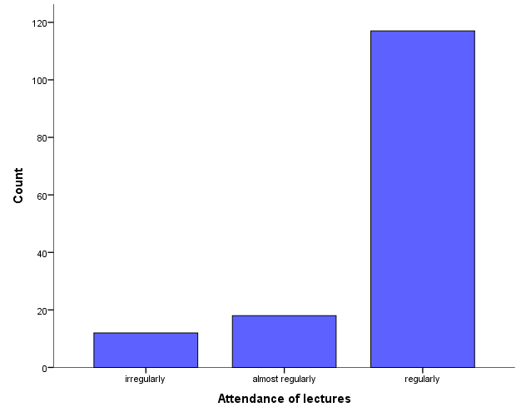

Figure 2. Regularity of holding lectures of the courses (N=148)
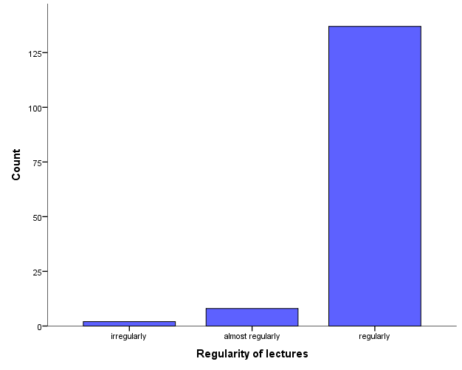

Contents of the courses and the study program
When it comes to the content of the courses attend by the students, the data show that 91% of respondents evaluate with the grade 4 (very good) or 5 (excellent) (Figure 3).

Figure 3. Satisfaction (1-5) of students with the content of courses (N=148)

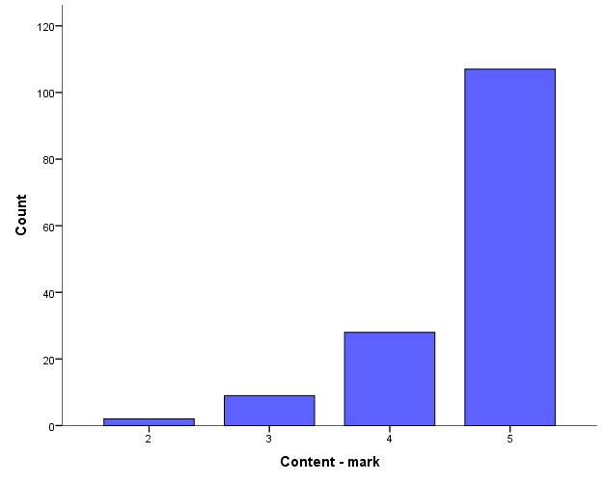
Concerning the questions related to the content of the study program / courses, most students from the University of Belgrade in the focus groups have agreed that the study program / course are interesting. The average assessment of the interesting contents of the course from the quantitative part of the evaluation of courses is one of the highest among the items for assessing the content of courses (4.59), and the study program as a whole even higher (4.8). Respondents have described the study program / courses with adjectives such as interesting, useful, practical, and up-to-date. According to the respondents, what made the study program / courses interesting are the acquisition of concrete knowledge and their practical application, as well as encouragement of the critical thinking.
The same opinion is expressed by students from the University of Niš, who evaluate the study program using the following adjectives: innovative, creative, applicable, incentive. The average rating of the interesting content of the courses from the quantitative part of the evaluation is the highest (4.86), and the study program as a whole is somewhat lower (4.5). The study program is a kind of challenge, which encourages the hope that it is possible to apply the acquired knowledge of a social pedagogue, who can help the society and especially groups and individuals who need any form of social protection. Social pedagogy is also rated as interesting because it is a completely new module. It is said that this is a small group of students, and hence there are great opportunities for working through debates and discussions, through expressing a critical approach to various problems in the field of social pedagogy. In other words, the study program provides great opportunities for creative and practical work, field work within research projects, with the belief that it will therefore be of a great benefit when students get employed somewhere after finishing the studies. It is also interesting that the study program enables the acquisition of practical, useful and modern knowledge that can be used for practical work in a contemporary school, and in the social protection institutions as well. It is indisputable that this study program is interesting because it develops different skills, such as interpersonal communication, leadership, solving some contemporary problems, and access to inclusion.
Students of the University of Novi Sad have evaluated the interest of the introduced courses with the highest score of 4.63 within the quantitative evaluation, while the interest rate of the study program as a whole is somewhat lower (4.40). On the other hand, the students have described the study program by using the following adjectives: "obscure, floating" (a respondent who sees the cause of this in the absence of students' obligation to attend classes, which is why the communication between a professor and a student has been mainly realized through consultations and correspondence by emails), "failed, chaotic, but the basic idea is good, "" experimental, insufficiently clear, "" unorganized, "" diverse, colorful, "" imprecise and somewhat frivolous, but promising ". However, it should be kept in mind that the results of quantitative analysis show that 33% of students in Novi Sad irregularly attended the classes, 30% of them attended the classes mostly regularly, and 37% of them attended the classes on the regular basis. It is also important to point out the possibility that such evaluation of the study program is obtained because the University of Novi Sad has 19% of employed students and 27% of volunteers, which is the highest percentage for all Universities in Serbia.
Belgrade students had different opinions about the representation of theoretical / practical questions. Most of them believed that practical questions dominated, three respondents believed that both theoretical and practical issues were equally represented, while only one respondent believed that theory was the one that dominated. Quantitative evaluation data shows approximately the same representation of theory and practice (the average estimate of the theoretical representation is 4.41, and the practice is 4.29, the difference is small, 0.12 in favor of the theory).
Similar answers were given by the students from the University of Niš. They think that both the theoretical and the practical questions are represented in the study program, that they are interconnected because this module provides a compulsory practice. Master studies envisage the possibility of developing a project within each subject, thus linking the theory and empirics. The respondents evaluate that through the implementation of the study program they have been offered great opportunities for expressing creativity, as well as for the practical work, fieldwork within research projects that enable them to meet with practice, which they assess as very useful and good. Quantitative evaluation data show approximately the same representation of theory and practice (the average estimate of the representation of the theory is 4.84, and the practice 4.54. Difference is 0.30 in favor of the theory).
When asked about the clarity and relevance of studied content, almost all the students of the University of Belgrade agreed that the contents were clear, relevant and concrete. Students emphasized the following:
Creative work is more emphasized, which is not just mere reproduction of literature, but it requires a critical opinion and the statement of views which we have in some areas, or having the smaller groups, so it is possible to work better. Only one student pointed out that some of the contents were confusing.
Students from the University of Novi Sad evaluated the clarity and relevance of the contents with a grade 4.4, which is a mid-rated item among the offered ones; the smaller number of students in the focus groups have seen the reason for the confusion of certain contents, despite the professor's great efforts, in the ‘disorganization’ of lecturers in the new field, while some respondents have seen the reason for the confusion in the nature of the content of the course and scope of topics included:
I think it's obvious that all professors are insufficiently prepared... the professors need a little bit more preparation.
Since the social planning and social development is a field that encompasses all the accomplishments of the society, entire development, involving many fields, I think that the clarity of the subject itself is lost. When we say social development, it does not mean only technological development, but it also refers to moral development, health status, children's rights, women, people, employment, poverty.
The focus group participants at the University of Niš agree that all teaching contents in this study program are excellent and adequately integrated into the module of the Social Pedagogy studies, which are useful and clear. All the contents of particular subjects, such as Inclusive Education, Social Pedagogy, Pedagogical Communication, are very important and equally important. They also agree that all elective subjects fit perfectly into the study program. It has been estimated that the selection of the subjects is quite relevant to the study module of Social Pedagogy. All subjects are important and interesting, and all the subjects can be equally useful for a job of the social pedagogues. A problem is that the offered four elective courses are equally interesting, and it is difficult to select only one. Hence, the proposal is to consider a different concept of the study program having in mind the need for studying, and the contents that are excluded with the choice of one subject. Therefore, as participants emphasize in the interview, the contents of the subjects in this study program are particularly relevant and applicable for those students who already have a job and know what the subject content is needed for higher quality performance and better work.
When it comes to the contribution of the contents of the study program in relation to the working role of the social worker, teachers at the Belgrade University have emphasized that the way of working with the beneficiaries is strongly related to the social work and about the social work. Sending the beneficiaries to the Social Services, and working with beneficiaries is in line with the universal approach in social work. Teachers have tried to create a subject in accordance with contemporary requirements of social work. The theoretical contents of the subject have a focus on significant areas in social work and social protection. The theory itself is relevant for understanding the essence of the subject, as well as for developing critical thinking, skills and ethical awareness in working with beneficiaries.
Teachers from the University of Niš evaluate the contents of the Master program Social Pedagogue as very well conceived as it contributes to the development of general competencies related to understanding, the need of trainees, and the characteristics of concrete social situations. The contents contribute to understanding of cause-and effect relationships and relationships in the context of various problems: inclusion, marginalization, stigmatization, victimization, ostracism, socialization and delinquency. The contents also refer to understanding and knowledge of all age structures of the trainees on the development of possible behavioral disorders, as well as on models of preventive actions, what is also a very important aspect in Social Pedagogy.
Professors from the University of Novi Sad also believe that the structure of the courses is functional, i.e. that the teaching content is relevant for achieving the set objectives of the study program and the outcomes, i.e. working competencies which should be acquired by the students. Justification is that the knowledge gained by students on the master studies from almost all subjects is useful for working in the social care system. Knowing the jobs that sociologists do in such environment:
I believe that broader knowledge in the domain of social policy, and also wider sociological knowledge of social inequality, etc., is extremely important, and that this broader knowledge is exactly the thing that is missing from the social welfare institutions, whether they are aware of this or not. So I think this is well thought out, although it may not necessarily look like this at first glance.
Also, as the professor of the second introduced course comments:
The content of the course I lectured, Social Security Systems, are very important because they open a general theoretical approach to social security systems and theoretical settings on one hand, while on the other hand students meet concrete examples that work in practice.
The focus group at the University of Novi Sad has shown that students do not transparently grasp at all for which jobs they specialize. It turned out that the outcomes of the program have remained vague to some students, i.e. what is expected from them to be able to do after the program is over, they doubt their qualifications:
The outcomes of these courses and this study program are unclear. It is not clear, we will get a diploma supplement where it will be written that we can work in social protection, but the question arises whether we really will have qualifications, because the outcomes are vague.
In contrast, participants in the focus group at the University of Nis clearly recognized the roles of the social pedagogue in the social care system, listing their tasks and where they can all work. They consider that they have, above all, a corrective-pedagogical role. They point out the following spheres in which social pedagogues should have, or already have, an important role: the implementation of inclusive programs (working with pupils and their parents), working with marginalized groups, prevention and suppression of violence, re-socialization. When it comes to whether there is a difference between the roles played by pedagogues and social pedagogues, students say that primarily pedagogues are engaged in the study of pedagogical literature and socialization, while social pedagogues perform corrective-pedagogical work, which includes creative activity and critical thinking, so that , as one participant points out, their role "has a width". Citing the experiences of developed countries, the participants recognize some other roles of a social pedagogue in dealing with homeless people, alcoholics, those who use national cuisines, also mentioning the need to engage them in, for example, the volunteer work, or even in the humanitarian work.

Quality of Courses and Study Programs
As it can be seen on a Chart, 81% of students assess the overall quality of teaching as very good (4) or excellent (5) (Figure 4).
Figure 4. Satisfaction of students (1-5) with the overall quality of courses (N=148)
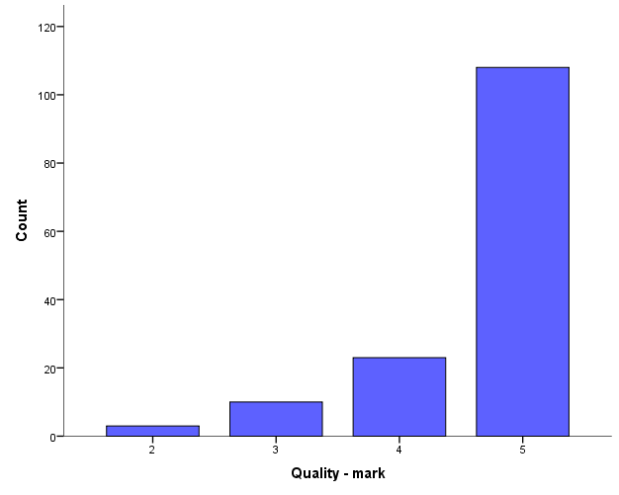

When asked about the quality of teaching, students agreed that the literature was adequate and useful, and that the classes were regularly kept, and that the lecture timetable was fixed, although there were times when classes were delayed.
The book we used is of a recent date, relatively recently translated into Serbian, so it's really great (UBG).
What I used, that's it. I would not change anything (UNS).
Finally, the focus group participants at the Universities in Belgrade, Nis and Novi Sad expressed their satisfaction with enrollment into a selected study program. As the most common reasons for such an attitude, they emphasized the acquisition of new knowledge and deepening of existing knowledge.
I am satisfied, because it is different from the undergraduate studies. We have more obligations, but it is more interesting and we are expanding our knowledge. So I'm pretty happy. (UBG)

Organization of Courses and Study Programs

Quantitative data show that 84% of all relevant students respondents assess the organization of work on the courses as very good (4) or excellent (5) (Figure 5).

Figure 5. Satisfaction of students (1-5) with the overall organization of courses (N=148)
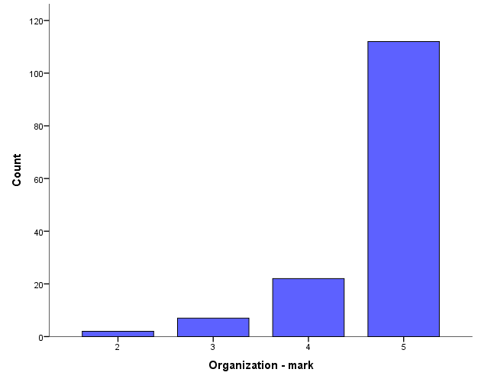

When it comes to the context in which the lessons take place, according to the results of the analysis of the data collected by the questionnaire regarding the assessment of the study program as a whole, 85% of students assess both the content and the organization of the program as a whole with the grade Very good (4) or Excellent (5). Even 90% of students evaluate the quality of teaching within the study program with the grades 4 or 5.
When asked about the organization of the study program, students of the Belgrade University praised the work of the Student Service and web-services. Also, they were unanimous in assessing the availability of literature and the adequacy of the rooms in which classes were conducted, stressing that literature was available and free of charge (on the module Social Policy), and that the rooms were adequate. There were no any complaints, not even on the timetable and the number of hours.

The respondents generally agreed that classes were practically organized and sufficient, while one respondent pointed out that the different dynamics of organizing lessons would be more useful. On one hand, due to working hours and the travel of the students who come from outside Belgrade, it is better that the classes take place on Saturdays. However, as this is then a full-time whole-day teaching (four hours for two subjects each), and the same subjects are taught every other week, there is a fatigue of students and a loss of continuity. On the other hand, classes that would take place four days a week, almost every afternoon with two hours for four courses each, would be a heavy burden for the students, and an unsustainable organization for those students who travel from other cities. This is illustrated with the answers which highlight both advantages and disadvantages of such an organization:
Different dynamics of organizing lectures would be more useful.
It seems to me that it is practically organized taking into consideration the people who are employed.
Because of people who do not live in Belgrade and because of those who work, I think its okay for classes to be on weekends in the form of a block of teaching, so they think the lecture timetable is basically good.
Lectures from one course take place every two weeks and are not properly distributed, so the continuity is lost. The interval between lectures is too big (two weeks), so most of us forget what was said at the previous lecture. Also, the classes last for three hours in continuity, and it is difficult to have a concentration of three hours.
Students of the University of Novi Sad were also satisfied with the lecture timetable, but the the term for exercises was not suitable for the majority. The assessment of the facilities, i.e. rooms in which the classes were organized were commented with the terms 'good', 'correct', 'appropriate' by all respondents. Characteristic of the UNS is that most of the students in the focus group were not satisfied with the work of the web service. Two students commented on the work of the Student Service, one expressing satisfaction with the answer and attitude of the Student Service, although quantitative data did not show that there was a problem in support of the Student Service:
I have a contact with the Student Service and they are totally okay.
while the other students expressed their dissatisfaction, because they could not get in contact with the Student Service:
When I try to call the Student Service, nobody answers the phone.
Students from the University of Nis estimated that the lecture timetable was fully suitable for them, especially because it was possible to make a correct agreement with teachers when something needed to be changed. A student's answer to the question about the number of hours of teaching and exercises is interesting:
... not too much, not too little, exactly as it should be.
It should be emphasized that this teaching is consultative, and unlike the classical teaching, it is held in the agreement with teachers ("professors always meet our needs"). This form of work is more suitable for every student. They assess this form of teaching as 'without a load'. It is worth considering an opinion of a student who thinks that consultative teaching is good for those who are from the Major study group, but that there is a need for classical teaching for those students who have not graduated from Pedagogy, and who need classical teaching as well.
There is an interesting answer of a student about the number of lectures and exercise classes:
... not too much, not too little, exactly as it should be.
When it comes to advantages and disadvantages / limitations regarding teaching organization, teachers from the University of Belgrade pointed out that they had a block of teaching, and that it was suitable for them, because the groups were smaller than on the undergraduate studies, and they managed to elaborate the topics entirely. As a disadvantage, most students noted an inadequate classroom for holding lectures, because exercise classes required an open space, rather than a classical listening room. However, in this respect, the Student Service mainly met their needs.
Suggestions for the improvement of the subjects were mainly focused on the implementation of more practical work and exercises, as this was assessed by teachers as extremely important.
Absolutely, there is a lack of practice, there is no any practical work on master studies, and there should be some.
All the interviewed professors from the University of Novi Sad realize that, although the teaching content of the courses is in function of the set goals, they are not sufficient for the creation of practical competences in students. It is precisely the question of acquiring work competences through more practical lessons recognized by the professors as a key spot for improving the study program. Also, this was the most discussed issue.
In order to implement the expected outcomes, it is not enough to have only theoretical knowledge and understanding, but it is necessary to have certain dose of application of the knowledge in the field, which should be then analyzed it and made some sort of synthesis of the acquired knowledge. We tried to make students go to the field, apply the research methodology they learned, and write their experiences and knowledge. This type of activity has contributed to the motivation of students to actively approach learning in subject ‘Social Security System’. Our goal was to connect theory and practice and to make knowledge relevant for work in the social protection system.

When assessing the contents of the Master's study program Sociologist in Social Protection, students of the University of Novi Sad note that the theoretical teaching content prevails, and that there is a need for the theory to be more connected to the empiric aspect and future jobs for the students. Therefore, a proposal for improving the study program is to pay more attention to the development of practice. The half of participants of the focus group expressed that they felt insecure to work in the profession for which they were trained:
Well, we have learnt something, but we are not sure if it is sufficient for practical work. We do not have a frame of reference in order to be able to compare it with anything in practice.
Yes, we obtained theoretical knowledge, but we lack a lot of practical work. I have learnt a lot about the human rights and I can apply this knowledge in the everyday life and conversation. I enriched my general culture knowledge, what again is not enough to work in the profession. I am trained to write the scientific papers.
Sociology students who are specialized in the field of social protection with this master study program have expressed the need to reorganize compulsory and elective subjects, and to separate sociologists who focus on work in education. Accordingly, the group that attends the new program should not listen to subjects related to education, and should have more subjects in the field of social work.
Students from the University of Novi Sad have made a proposal to improve the study program. Their common assessment is that classical lectures at this level of studies have been overcome, and that it would be very useful to organize thematic lectures related to some field of social pedagogy, either at the faculty or at some seminars where students would have an access.

Satisfaction with the work of Teachers and Associates
The chart shows that 96% of all surveyed students have assessed the work of teachers with the grade Very good or Excellent (Figure 6). Assessments of work of the teaching assistants were given by 46 students who attended organized exercise classes within the selected subjects. Out of these students, even 44 of them evaluated the work of assistants as excellent. It should be noted that the exercise classes were not organized separately in 20 out of 30 courses within all evaluated programs, but the exercise classes were included in the term of lectures, through active teaching methods. For this reason, assessment of work of the teaching assistants on exercises is missing by a great number of students.

Figure 6. Students’ satisfaction (1-5) with the work of teachers on the courses (N = 148)
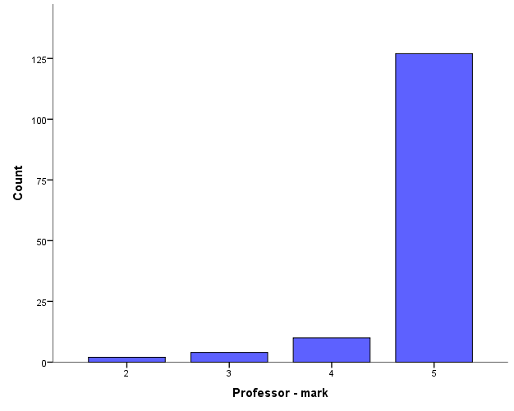

All students evaluated the attitude of teachers towards them as correct: 'maximally correct' and 'evaluated as objective' (UNS), 'totally correct' (UNI).
The relationship is better than on undergraduate studies. Due to smaller groups, communication between professors and students is better and relations are correct. (UBG)
All professors were available to us. We could contact them via mail concerning all the dilemmas we had in relation to the particular course. Relationship is satisfactory. (UBG)
Focus group participants at the University of Novi Sad point out that at the beginning of the semester all teachers introduced students with the rules and methods of realization of established pre-requisites (essay, seminar work, project ...), so there were no problems. There was also the possibility of improving the grade obtained at pre-requisites activity. All students evaluate the relation-communication between the teachers and students as positive, with the prevailing qualifications:
'Correctness, flexibility, openness, partnership'.

Impact
When it comes to the impact of the courses and their relevance to the expected outcomes, we find that 93% of students assess that the courses as a whole are useful for them (Figure 7). A more detailed analysis of the students' responses to some items related to the impact of courses indicated that 94% of students believed that the courses were very or extremely useful for acquiring new knowledge, while 88% of them gave them the same grades for the acquisition of skills, and 89% of students gave the assessment for acquiring professional competences. Also, 89% of students believed that courses were very or extremely useful for gaining critical thinking, 88% of them considered the courses to be very useful for creation of the professional attitude, while 92% of students thought that their courses developed potentials for lifelong learning and advanced training.
When asked about the impact of the study program / courses, the students of the University of Belgrade pointed out that the most important things they learned from the study program / courses were the following:
That I still need to learn.
There are numerous perspectives, and it is on us to decide which one we will use in further work.
The most important thing for me was the knowledge that we do not know how much we think we know, i.e. that we enroll the studies with too many assumptions. Perhaps this is best illustrated with the comment of prof. Jasna
a: "You enter the therapeutic process as if you do not know anything, because you actually do not know, and you have to find out everything from the beneficiaries. This is useful to apply on a daily basis, because it can help us a lot to get rid of assumption and, prejudices...

Figure 7. The students’ assessment of the impact of the courses on the expected outcomes (N=148)
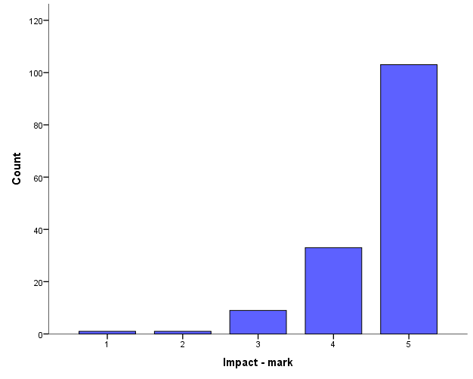

The approach of the professors, the work in small groups, practical tasks and concrete examples, are things that the respondents pointed out in most cases as things that helped them most in acquiring new knowledge.
Certainly, because it was a small group, the closeness of the professor when it comes to work in a smaller group. We were more relaxed for work and communication, as well as for practical exercises.
The most helpful to me were the concrete examples and simulation exercises in which we participated, as well as the fact that the rest of our colleagues and professors corrected us if we made a mistake, and helped us if we needed help.
Respondents most often emphasized role-play, listening skills, reflexive diaries, the tree problems, and goals as specific skills / knowledge which they adopted. Also, respondents were unanimous in assessing that the acquired knowledge / skills prompted their critical thinking.
Respondents affirmatively and almost unanimously answered the question about the readiness for work in the social protection system. Everyone agreed that after the completion of the study program / courses they were more willing to work in the social protection system, of course, with adequate mentoring.
I think that I am ready to work in the social protection system with adequate mentoring.
I feel more prepared in the sense that this course has somehow raised my self-confidence. Now I have a clearer structure of what I should do, what I can and cannot ask, what should I say, how I should behave - it gave me some guidance and increased self-confidence for a bit.
I feel more prepared to work because I have acquired some skills that I can apply not only in the professional work, but also in everyday life.
Students participants in the focus group at the University of Niš emphasize the benefit of the study program, the forms of new knowledge, such as inclusive education, peer violence - access to the problem, preventive actions, advisory discussions, encouragement of the pro-social behavior, pedagogical communication, empathy, conflicts, different types of research and ways of their implementation. According to the students’ opinion, all the new knowledge contributes to strengthening of the self-confidence. A special emphasis is placed on the acquisition of skills, out which the respondents distinguish the skill for advisory work (special types, modes), training for conducting research as well as the conversation skills, organizational skills, computer literacy, leadership and teamwork skills.
Focus group participants assess that courses and study programs have encouraged them to critical thinking and expression of a critical attitude, as well as a desire to further improve in the field. E.g.:
... we are much more critical ourselves and aware of the fact that we can give much more with our critical reflection on what we do, and what we write, because we have awareness of all of this.
Yes, they certainly encouraged us. I generally enrolled the study program Social Work because I really wanted it, and this only deepened my desire even more to continue to gain new knowledge, both theoretical and practical, from this field. I would add that they gave us a solid basis for further advanced training.
However, participants in the focus group at the University of Novi Sad, those who already work in the profession, think that they are more stimulated with the work they already do than with the master program: .
For me this certainly is the encouragement, but I do not know to which extent it was influenced by this study program, and to which extent it is actually the influence of the work I already do.
I do not know, maybe ‘yes’ the same as my colleague, through my work.
One respondent was contradictory in her view towards the master program – to the question on the encouragement of the study program, she reacted exclusively negatively:
It did not personally encourage me. If I could, I would go back to Sociology. If I could, I would enroll a regular master.
However, at the end of the conversation she claimed that she "is generally satisfied" that she enrolled this master program.
When it comes to the usefulness of the courses in terms of developing competencies and skills as well as lifelong learning, all teachers at the University of Belgrade pointed out that the courses were formulated to include mastering of the required skills, leaving space for continuous improvement. Teachers have stated that the courses develop critical thinking and consider the ethics of social work. Teamwork, collaboration, and error-based learning, are also an integral part of the courses.
Teachers from the University of Niš believe that the Master Academic Studies in Pedagogy, the module Social Pedagogue, also contribute to the development of the competences of social pedagogues, training them for the lifelong learning, self-education and continuous improvement. Namely, the contents of the study program form the work competences of the social pedagogue through the willingness to work with individuals, groups and communities at risk. Also, they are useful for work on prevention, diagnosis, intervention and treatment, processing and subsequent care for children, young people and adults with disorders, or behavioral disorders, in the function of upbringing, re-education, socialization, rehabilitation or social integration.
Half of the interviewed professors at the University of Novi Sad believe that lifelong learning predominantly depends on the person, but that perhaps
'There was a lack of a stronger initiative by the professors to encourage people to continue with their advanced training and improvement after the studies.'
"I think we have managed to develop in students the autonomy in learning and curiosity in research, which is the basic meaning of lifelong learning. On one hand, the feeling that they are not ready enough for a working role makes them to go for an advanced training in order to get improved, and on the other hand, the changes brought by life and technology also compel them to learn.'

A COMPARATIVE ANALYSIS OF THE DIMENSIONS OF THE USEFULNESS OF COURSES IN THE FIVE STUDY PROGRAMS
When it comes to the usefulness of the study program, quantitative data show that 85% of all surveyed students evaluate the study program with grades 4 or 5. It is interesting to find that the dimensions of the usefulness of courses do not behave uniformly when students’ grades are positioned within the evaluated study programs. Figure 8 shows that some programs are differently efficient, while some other study programs are uniformly efficient in the development of six measured outcomes compared to other study programs. For example, the study program 'Social Policy Master Sociology' program has an uneven contribution to achieving outcomes where the development of skills, as well as the development of a professional attitude goes below the grade 4. According to students’ assessments, the program 'Social Pedagogy: Master Pedagogy' is equally good in contributing to achieving all measured outcomes.

Figure 8. Students’ grades-evaluation of the outcomes according to the individual study programs (N=148)
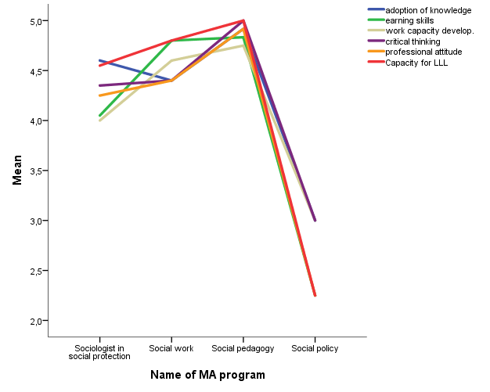

Evaluation – Grades of the Process and Outcome of the Study Programs Analyzed Together
If we compare the Universities where the study programs take place, the dimensions of the satisfaction, and usefulness of the study program, we will see that they are distributed differently (Figure 9).
Figure 9. Students’ satisfaction and outcomes of the study programs according to the individual Universities (N=41)
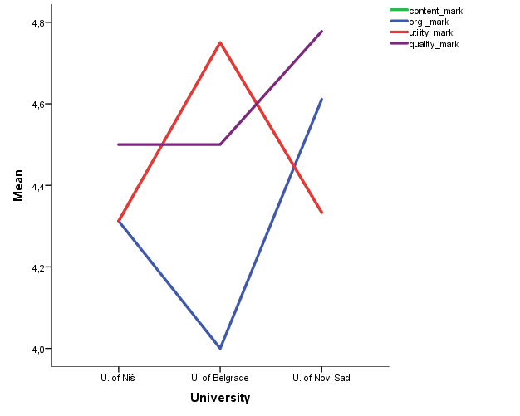
It can be noted that Universities differ in measured dimensions, and that some of them are more uniform in these dimensions than some others. The biggest inconsistencies in the evaluation are found in the case of the University of Belgrade, and the least inconsistencies are found at the University of Niš. Evaluation of the organization and the quality of lectures carried out at the University of Novi Sad are more in relation to the grades at the other two universities. It is also clear that the grade of the usefulness of the study program is the highest in the case of the University of Belgrade, and at the same time, the lowest grade for the organization of the study program has been evaluated at the same University.

Strengths, Weaknesses, and Recommendations of Students and Teachers

Students
When it comes to the positive aspects of the courses, the students have often mentioned dedication and professionalism of teachers, the organization of courses, working in small groups, interesting course, and its importance for practical work.
Weaknesses have been recognized in insufficient number of classes, the insufficient information regarding student requirements, insufficient hours of practical lessons, difficulty in teaching due to large groups of students, and lack of literature in the Serbian language
The students’ recommendations for the improvement of teaching the courses are complementary with the noted weaknesses:
- more teaching hours / classes,
- introduce exercise classes where there are no any,
- introduce the practicum internship in the Centers for Social Work or Social Protection
- more books in the library
- more projects during the teaching in order to enable students to connect the theory knowledge with practice (UNI)
- make some changes in the study program in order to enable students to have better assess to the contents and the elective subjects which they did not elected, but which are useful for their future work (UNI)
- consultative teaching has its advantages, but some key topics should be elaborated at the classical teaching (UNI)
- 'I think that there should be more courses dealing with social planning, social work and social protection, and less pedagogical courses.' (UNS)
- '...it is necessary to separate teaching methods and practicum courses, where the teaching methods courses should be elective, and the courses related to the social work should be compulsory.' (UNS)
- 'Teaching methods practicum could be adjusted to the nature of the course, and it should not be limited only to schools, but it could be carried out in the Centers for Social Work, Hangouts, etc.' (UNS)
- To introduce new courses: 'Social Pathology' and 'the course dealing with the work with a client' (UNS)
- More practicum classes(‘The study program is interesting, but it should be supported and enriched with practicum classes’.) (UNS)
- 'A proposal for social development and planning is to introduce a practicum part in the form of a task where students would be required to write a form of work and strategy in the field that belongs to social development. Just in order to have a feeling of the practical moment’. (UNS)
Teachers
Concerning the positive aspects of the courses and the study program, the teachers state the following:
- variety of offered courses and competencies of teachers who implement courses; a special value is a great number of elective courses, interdisciplinary and a multidisciplinary approach in the realization of defined goals and outcomes; a special value of this program is co-operation, both in the work among students, and in the work among the professors and lecturers, interactive approach in the content implementation and insisting on active participation of students (UNI)
- The program complements knowledge of sociologists who are already employed or volunteered, and encourages them to participate in lifelong learning (UNS).
- Teachers emphasize that a block of classes suits them, because they manage to elaborate the topics as a whole, since the groups are smaller than at the undergraduate studies. (UBG)
- Regarding the negative aspects of the courses and the study program, teachers state the following:
- • Inadequate classrooms, since the exercise classes require an open space and not classical classrooms. However, in that respect, the Students Service mostly met their requirements. (UBG)
Interviewed teachers have emphasized the following suggestions for improving the study program:
- One teacher considers that there is no need to improve this study program, one teacher does not want to comment it, and one teacher believes that there is always room for improvement (UNI)
- 'For the next year I would organize a meeting of cohorts of old and new students with practitioners. The meeting would be advisory, and it should be held at the faculty after the examination period, where they would outline the results of their research that they did as the exam requirement. Thus, their knowledge could be tested in the peer discussion and questions of practitioners. It would be a confrontation between the possible and the real. ' (UNS)
- To introduce more courses '... which more apply to practical competences, more practical work of students through workshops and courses created as the role-playing with going through some potential situations that occur in practice in everyday work. (UNS),
- Go to individual groups that occur as beneficiaries of the social protection system, and develop courses that will deal with social work together with educational institutions, elderly, and people with disabilities'. (UNS)
- 'Distinguish the course and the time for professional practice (internship) in social care institutions.' (UNS)
- • 'Concerning the contents or some other practical spheres, I think that further improvement of certain aspects of the study program would be good ...,' for example ... 'if we have a course ‘Urban problems’ on the Master Program for Sociologists in Social Protection, a part of the course with the general knowledge should be applied to the domain of social protection. Teachers should apply materials to one narrow specialized area. '...' to hear something a bit more about e.g. urban problems in concrete cases. ' (UNS)
- It is necessary to better advertise the need for sociologists in the social system. (UNS)
- More practical work and practicum exercises are needed, as this is assessed by teachers as extremely important for the success of the program. (UBG)
- • In the future, to reduce the number of theoretical, political subjects and expand the fund of classes of existing courses, or enrich the contents of the program with some other courses relevant to social protection, although at the moment it is not realistic. (UBG)

Discussion and Recommendations

Within the discussion, a review will be made of the main findings related to the process and the usefulness of courses and programs, taking into consideration the set objectives of the evaluation.
Within the evaluation of the PROCESS, there have been examined the following: regularity of attendance and keeping of classes and consultations, satisfaction with the contents and organization of teaching, as well as the pedagogical work of teachers and associates.
Regarding the regularity with which students attend classes and use consultations within evaluated courses and study programs, it has been registered that the majority of surveyed students, over 80% of them, regularly attend lectures on courses and evaluate that teachers keep their lectures on a regular basis. Those who are irregular in attending lectures are either employed or volunteered in the profession. Also, the vast majority of almost 90% of students believe that professors and teaching assistants regularly hold consultations within their courses.
Within this goal, it was obtained that satisfaction with the content of courses and programs is highly rated by students. More than 90% of respondents give the highest marks (very good or excellent) when evaluating the content of the courses they attended.
Satisfaction with the content was also examined by the focus group method, within which there was a possibility for students to present in detail and explain their opinions and attitudes. Students at the universities in Belgrade and Nis have declared that the programs, as well as the individual courses, are interesting, useful, practical and up-to-date. By the method of the focus group, students of the University of Novi Sad were slightly less satisfied with the study program, which was described as insufficiently clear, with insufficiently defined requirements.
The work of teachers and associates is rated with high marks. Namely, 96% of all surveyed students gave the highest marks (very good or excellent) for this parameter.
When it comes to organization of courses and programs, the results show that more than 80% of all respondents assess the organization of work in the courses with the highest marks (very good or excellent).
The method of focus groups has identified specific sources of (non-) satisfaction, and suggestions for improving the content and organization of study programs and courses. The general assessment of students covered by the focus groups is that traditional classroom lectures at the master level of studies have been overcome, and that it would be useful to organize a thematic block teaching at the faculty, or even in some other institutions, where students could gain useful knowledge for their (future) professional role. (Only students at the Department of Social Pedagogy, who did not complete the undergraduate Pedagogy studies, expressed the need for additional theoretical knowledge, which would be gained within traditional teaching.)
When it comes to the teachers’ evaluations, suggestions for improving the subjects were mainly focused on more practical work and exercises, as this was assessed by teachers as extremely important. There was expressed a need for teaching to be more closely related to the empiric and future jobs for students.
In specific centers, some specific proposals have been formulated. For example, in Belgrade there was a need to maintain a block teaching, in which some topics would be dealt with comprehensively, since groups are smaller than on the undergraduate studies.
The shortcomings pointed out by teachers were mostly of a technical nature, such as, for example, inadequate room for teaching.

The following data are obtained from teachers and students as a part of the evaluation of the USEFULNESS of courses and study programs in relation to the work role of the social worker.
When it comes to the usefulness of courses and programs, and their relevance to the expected outcomes, we find that more than 90% of students evaluate that courses and programs in general are useful for them. A more detailed analysis of the students’ responses on individual items shows that the vast majority of students evaluate that courses have been useful for acquiring new knowledge, acquiring skills and acquiring professional competencies. Also, students think that courses are very or extremely useful for acquiring critical thinking, forming a professional attitude, as well as the potentials for lifelong learning and improvement.
It can be noticed that Universities differ in measured dimensions, and that some of them are more uniform in terms of the measured dimensions than others. The greatest unevenness in the evaluations is found in the case of the University of Belgrade, and the least unevenness is found in the evaluations of the University of Niš.
Interviewed teachers stressed that courses and programs are strongly linked to professional activities in social work. Teachers tried to create subjects in accordance with contemporary requirements of practice in the field of social work. Theoretical subject contents have a focus on significant areas of social work and social protection, thus enabling understanding of the essence of the subject, as well as the development of critical thinking, skills and ethical awareness in working with beneficiaries.
Certain disagreement between the evaluation of the relevance of programs and courses for future activities in social work was observed between teachers and students at the University of Novi Sad, where it was shown that students in Novi Sad did not have a quite clear idea of the usefulness of the study program / courses for (future) professional role, as well as knowledge of the jobs for which they chose to be specialized.
Revisions of study programs proposed on the ground of the evaluation data collected during the period of this Work Package.
Based on the obtained results, the recommendations for further development of the program can be clearly formulated.
- Taking into consideration that the work of teachers and associates is highly evaluated, their motivation must be nurtured and maintained at a high level, among other things, by providing feedback on the results of the evaluation.
- - The contents that are being processed within courses and programs, as well as the organization of classes, are highly rated. It is found that there is little less satisfaction of students in Novi Sad, which is partly explained by the working structure of students at this University. Namely, compared to other Universities, there are significantly more students who are either employed or who volunteer in the profession, which is why they are not able to attend regular classes / part time consultations within the program.
- Suggestions for the improvement of courses and programs, which have been received from students and teachers, point to the need to organize a part of teaching outside the classical academic space, i.e. in the institutions where students could gain more knowledge about the profession of the social worker.
- Also, the teachers have clearly formulated a suggestion that more attention should be paid to the development of practice within the study programs.
- - Finally, the data obtained in the evaluation indicate that it is necessary to monitor the implementation of programs and courses in each of the university centers, taking into account the specific characteristics of every program.

Conclusion
Within the framework of the Tempus project SHESPSS, there has been carried out an evaluation of the study programs in the field of social policy and social protection, focused on the organization and contents of study programs, on the attitude of students and teachers towards them, and on the strengths and weaknesses and improvement of these programs. Based on the survey, the focus groups with students and individual interviews with teachers have established that students are satisfied with the efforts and expertise of teachers, the organization of courses. However, they also pointed to the insufficient information regarding students' obligations, the lack of practical classes, difficult teaching due to the overloaded groups of students at one University, as well as the lack of literature in the Serbian language. According to the recognized shortcomings, there have been given recommendations for improvements in the organization and implementation of these study programs.

Acknowledgments
We would like to thank the European Union Tempus Program for co-financing the costs of implementing the SHESPSS project, as well as the evaluation of the study programs in the field of social work and social protection that are being conducted at Universities in the Republic of Serbia.

Reference
Alkin, M., Vo, A, & Hansen (2012). Using logic models to facilitate comparisons of evaluation theory. Evaluation and Program Planning, 38.
Blackmore, J. (2009). Academic pedagogies, quality logics and performative universities: Evaluating teaching and what students want. Studies in Higher Education, 34, 857–872.
Chalmers, D., & Gardiner, D. (2015). The measurement and impact of university teacher development programs. Educar, 51(1), 0053-80.
Contandriopoulos, D., & Brousselle, A. (2012). Evaluation models and evaluation use. Evaluation, 18(1), 61-77.
Creswell, J. W. (2009). Mixed Methods Procedures. In Research design: Qualitative, quantitative, and mixed methods approaches-3rd ed. Sage publications. Inc, 203-224.
Frechtling, J. (2007). Logic modeling methods in program evaluation. San Francisco: Jossey-Bass.
Harvey, L. (2007). Epistemology of quality. Perspectives in Education, 25(3), 1-13.
Julnes, G., & Bustelo, M. (2014). Professional values and ethics in evaluation. American Journal of Evaluation, 1098214014549069.
Miller, R. L. (2013). Logic models: A useful way to study theories of evaluation practice?. Evaluation and program planning, 38, 77-80.
Miron, Gary (2004). Evaluation Report Checklist. (https://www.wmich.edu/sites/default/files/attachments/u350/2014/evaluation-reports.pdf, pristupljeno 22.06.2016.)
Nevo, D. (1983). The conceptualization of educational evaluation: An analytical review of the literature. Review of educational research, 53(1), 117-128.
Newcomer, K. E., Hatry, H. P., & Wholey, J. S. (2015). Handbook of practical program evaluation. John Wiley & Sons.
Patton, M. Q. (2002). Qualitative research and evaluation methods (3rd ed.). Thousand Oaks, CA: Sage Publications.
Patton, M.Q. (2012). Essentials of Utilisation-Focused Evaluation. Thousand Oaks, CA: Sage.
Payne, D.A. (1994). Designing educational project and program evaluations: A practical overview based on research and experience. Boston: Kluwer Academic Publishers.
Scriven, M. (2012). Conceptual revolutions in evaluation. In M. C. Alkin (Ed.), Evaluation
roots: A wider perspective of theorists’ views and influences (2nd ed.). Thousand Oaks,
CA: Sage.
Scheerens, J, Glas, C & Thomas, SM (2003). Monitoring and evaluation (M&E) in Education: Concepts, Functions and Context', Educational Evaluation, Assessment and Monitoring, vol. 1, pp. 3‐16.
Stevahn, L., King, J. A., Ghere, G., & Minnema, J. (2005). Evaluator competencies in university-based evaluation training programs. Canadian Journal of Program Evaluation, 20(2), 101.
Stufflebeam, D. (2001). Evaluation models. New directions for evaluation,2001(89), 7-98.
Stufflebeam, D. L. (2003). The CIPP model for evaluation. In International handbook of educational evaluation (pp. 31-62). Springer Netherlands.
Tourmen, C., & Droyer, N. (2013). Dialogues entre théories spontanées et théories académiques de l’évaluation. Mesure et évaluation en éducation,36(3), 25-49.
Zhang, G., Zeller, N., Griffith, R., Metcalf, D., Williams, J., Shea, C., & Misulis, K. (2011). Using the context, input, process, and product evaluation model (CIPP) as a comprehensive framework to guide the planning, implementation, and assessment of service-learning programs. Journal of Higher Education Outreach and Engagement, 15(4), 57-84.

Attachments
Forms and protocols for data collection:

Consent form for students’ participation in the focus group

University of Novi Sad
Faculty of Philosophy
TEMPUS project
Strengthening Higher Education for Social Policy making and Social Services delivery
Consent Form
- I confirm that I have been informed about the focus group in relation to this research and the Tempus project, and that I have had the chance to ask questions on this subject.

- I understand that my participation in the focus group is voluntary and that I can leave it at any moment without justification.

- I consent to participate in the focus group whose purpose is to evaluate the study program within the TEMPUS project SHESPSS.
- I consent to having the focus group recorded.
- I consent to having my answers quoted anonymously.
Name of participant Date Signature

Name of researcher Date Signature

Consent form for professors’ participation in the interview

University of Novi Sad
Faculty of Philosophy
TEMPUS project
Strengthening Higher Education for Social Policy making and Social Services delivery
Consent Form
We invite you to participate in evaluating the new study program Sociologist in Social Protection, by giving an interview as one of the lecturers on this program.
During the interview you will be asked about the content and organization of the study program, as well as to assess how well the program has fulfilled its objectives up until now. Your insights, opinions and comments will help us improve this program for future generations.
We request your consent to record the interview, so that it may be used for further analysis. All information obtained from during the conversation will be used solely for the purpose of evaluation and you will remain anonymous, so we ask that you answer the questions honestly and openly.
Access to personal information of the interviewee has only the coordinator of the evaluation, whose work is monitored by an independent body- Committee for Quality of the Tempus Project, SHESPSS, which is funded by the European Commission.
Please note that your participation in the interview is voluntary and that you may, at any moment, stop the conversation without explanation. If you consent to being interviewed, please sign this consent form.
Name of participant Date Signature
Name of researcher Date Signature

Focus-group protocol

Protocol for Leading the Focus Group

University of Novi Sad,
November 2015.
Introduction to the Conversation

Hello, my name is. ........and I am from the faculty of ............ .
We have gathered here to discuss the new study program „Sociologist in social protection.“ Your insights, opinions and comments will help us improve this study program for future generations, for which reason we have organized this focus group, that is to say, research and discussion group. I have been appointed to lead the discussion.
You have been chosen to participate in this focus group and to evaluate the mentioned study program, as you are its first students .. If you have not until today participated in a focus group, you will see that it is a very relaxed, „painless“ research technique, through which we wish to openly discuss your experiences on this master program.
I hope you will permit this conversation to be recorded, so it can be used for further analysis. Everything you say remains confidential, and will be used only for the purposes of evaluation, so please answer honestly and openly.
Here are some guidelines I would like you to keep in mind during the discussion:
- Everyone should participate in the conversation,
- All your opinions are equally valid,
- There is no right or wrong answers,
- Everyone's voice should be heard and respected.
Therefore, there are no „winners“ or „losers“ in the focus group, and this is not an „interrogation.“ Feel free to express your opinions and disagree amongst yourselves, within the bounds of tolerance and respect. Thank you in advance.

Content of the study program
Taking into account your experience so far on this master program...
Would you say that this program is interesting? If yes/no- Why?
Would you say that theoretical or practical fields are prevalent in this program?
How do you now understand the role of the sociologist in the system of social protection?
What do you think of the content studied on this master program? Was it clear? Was it relevant?
What words (adjectives) would you use to describe this master program?

Organization of the study program
Moving on to more practical questions... Was the lecture timetable agreeable?
Do you think that there are too many or too few classes?
What is your opinion on the working environment in which classes were held (classrooms, equipment, etc)?
How would you evaluate the accessibility of the library? The work of web services and Student Services?

Utility of the study program
What is the most important thing you have learned during this program? Why?
Can you comment on some of the knowledge you acquired?
And on some of the skills?
Would you say that some of the subject matter gave you an opportunity to practice critical thought?
Do you feel ready or more ready for work in the system of social protection? Explain.
Do you think that you can continue to improve in this area?

Quality of teaching
Would you say that classes were held regularly?
Did you use computers and other information communication technologies during lectures?
Was the literature you used adequate?
Were teachers unbiased when grading?
How would you assess the attitude of teachers toward you?
Finally, are you satisfied to have enrolled in this master program?

Interview protocol for teachers

STUDY PROGRAM EVALUATION INTERVIEW PROTOCOL FOR TEACHERS

University of Novi Sad,
November, 2015

GENERAL INFORMATION

Name of the study program: | MA program of Sociologist in Social Protection

EVALUATION OF THE STUDY PROGRAM

The aim of the Master degree program Sociologist in social protection is to provide students with competences needed for work in institutions of social protection and social security. They are expected to demonstrate these competences in the areas of business planning and development at different levels of governance. They are also expected to develop their capacity to further train for work in scientific and research institutions.
Please reflect on the content and organization of this program and evaluate the extent to which the program as a whole has achieved its goals. The purpose of this interview is to obtain opinions of teachers involved in this program and, on this basis, to take steps in improving the content and organization of the study program. All collected data will be used exclusively for the purpose of evaluating this study program. To your personal data access has only the Project Coordinator whose work is monitored by the Quality Committee of the Tempus project SHESPSS funded by the European Commission. The conversation will be sound recorded or taken as written notes depending on what you agreed upon.

Topics:

- The relevance and clarity of the study program content for the future role of sociologists in the social protection system:
  - How helpful are courses in achieving the goals of this program?
  - How clear is what it can be achieved by the courses within this program?

- In your opinion, how are the objectives of this study program connected with their expected outcomes?

- Contribution of the program content preparing students for the role of sociologists in social protection:
  - How useful is program content in developing working skills and professional attitudes in students?
  - How useful is it in developing potential for lifelong learning and further training?

- How do you evaluate the organization of this study program?

  - What do you commend?
  - What do you perceive as weakness?

- How would you improve this study program?

- Is there something else you find relevant to the realization of this program that we have not mentioned in this interview?

Student Course Evaluation Questionnaire

Student Course Evaluation Questionnaire

University of Novi Sad,
November, 2015

GENERAL INFORMATION
Name of the study program: | MA program of Sociologist in Social Protection
Course name:
Semester (circle): | Winter | Summer
Gender: | Male | Female
Working status (circle one): | Employed in the Field Volunteer in the Field Unemployed
Average mark of previous studies: | ____________________________
Student financial status: | Scholarship | Self financed | Foreigner

The list of items bellow pertains to the course you selected within your program of study. According to experience gained while attending the course, please assess its properties using a scale of 1 to 5. The meaning of these numbers has been given separately for each group of items.

- Teaching and consultation

Please circle one of the numbers next to each of the items below, which concern lectures and exercises conducted within the course. If the Assistant was not engaged, items referring to exercises and the Assistant leave unanswered.

Within this course, I attended lectures | 1 – never | 2 - seldom | 3 – irregularly | 4 - mostly | 5 – regularly
Lectures took place | 1 – never | 2 - seldom | 3 – irregularly | 4 - mostly | 5 – regularly
The Professor held consultations | 1 – never | 2 - seldom | 3 – irregularly | 4 - mostly | 5 – regularly
I attended exercises | 1 – never | 2 - seldom | 3 – irregularly | 4 - mostly | 5 – regularly
Exercises took place | 1 – never | 2 - seldom | 3 – irregularly | 4 - mostly | 5 – regularly
An Assistant held consultations | 1 – never | 2 - seldom | 3 – irregularly | 4 - mostly | 5 – regularly

- Evaluate the following aspects of the course CONTENT, where 1 means unsatisfactory, and 5 excellent.
Clarity in defining the objectives and contents of the course in syllabus is ... | 1 |  | 2 | 3 | 4 | 5
Literature proposed for realization of the course is ... | 1 |  | 2 | 3 | 4 | 5
Clarity and intelligibility in presenting course content is ... | 1 |  | 2 | 3 | 4 | 5
Compatibility of course content with the objective of the course is ... | 1 |  | 2 | 3 | 4 | 5
Attractiveness of the course content is… | 1 |  | 2 | 3 | 4 | 5
Representation of theory in course content is ... | 1 |  | 2 | 3 | 4 | 5
Representation of practical content in the course is ... | 1 |  | 2 | 3 | 4 | 5
Contribution of course content to development of the professional competence of sociologists in social protection is... | 1 |  | 2 | 3 | 4 | 5
Compatibility of course content with other courses is ... | 1 |  | 2 | 3 | 4 | 5
General rating of course content | 1 |  | 2 | 3 | 4 | 5
- Evaluate the following aspects of the QUALITY of TEACHING, where 1 means unsatisfactory, and 5 excellent.

A variety of teaching methods is used in the realization of the course | 1 | 2 |  | 3 | 4 | 5
Suitability of applied teaching methods to course content | 1 | 2 |  | 3 | 4 | 5
Use of information-communication technologies while teaching | 1 | 2 |  | 3 | 4 | 5
Availability of feedback about student progress during the course | 1 | 2 |  | 3 | 4 | 5
Availability of required literature | 1 | 2 |  | 3 | 4 | 5
Compliance of course requirements with the number of ECTLs | 1 | 2 |  | 3 | 4 | 5
General rating of teaching quality | 1 | 2 |  | 3 | 4 | 5

- Evaluate the UTILITY of the course for attaining curricula defined outcomes, where 1 means that the program was not at all useful and 5 that it has been extremely useful, for…

Adopting knowledge | 1 | 2 | 3 | 4 | 5
Acquiring skills | 1 | 2 | 3 | 4 | 5
Developing professional competence | 1 | 2 | 3 | 4 | 5
Development of critical thinking | 1 | 2 | 3 | 4 | 5
Building a professional attitude among students | 1 | 2 | 3 | 4 | 5
Creating the potential for lifelong learning and further professional development | 1 | 2 | 3 | 4 | 5
General rating of course utility | 1 | 2 | 3 | 4 | 5

- Evaluate ORGANIZATION of the course, where 1 means unsatisfactory, and 5 excellent.

Lecture timetable is | 1 | 2 | 3 | 4 | 5
Exercise timetable is… (or mark N/A here if there are no exercises within this course) | 1 | 2 | 3 | 4 | 5
The number of classes per week is… | 1 | 2 | 3 | 4 | 5
Equipment of classrooms in which lectures take place is | 1 | 2 | 3 | 4 | 5
General rating of course organization | 1 | 2 | 3 | 4 | 5

First and last name of the teacher on this course: _________________________
- Evaluate the WORK of the TEACHER, where 1 means unsatisfactory, and 5 excellent.

Professor clearly and understandably presents course material | 1 | 2 | 3 | 4 | 5
Lectures are well-prepared and organized | 1 | 2 | 3 | 4 | 5
Professor is willing to answer students’ questions | 1 | 2 | 3 | 4 | 5
Professor encourages students to participate in the class | 1 | 2 | 3 | 4 | 5
Professor strives to make course material interesting and useful | 1 | 2 | 3 | 4 | 5
Professor is unbiased when grading students | 1 | 2 | 3 | 4 | 5
Professor is punctual in giving information about the evaluation criteria | 1 | 2 | 3 | 4 | 5
Professor continuously evaluates students’ work during the course | 1 | 2 | 3 | 4 | 5
Professor encourages open communication with students | 1 | 2 | 3 | 4 | 5
Professor encourages students to cooperate amongst themselves | 1 | 2 | 3 | 4 | 5
General rating of the work of the teacher | 1 | 2 | 3 | 4 | 5

First and last name of the teacher’s assistant on this course: ________
(If the Assistant is not engaged on this course leave items under 7 blank and skip to Comment)

- Evaluate WORK of the ASSISTANT, where 1 means unsatisfactory, and 5 excellent.

Assistant clearly and understandably presents course material | 1 | 2 | 3 | 4 | 5
Exercises are well-prepared and organized | 1 | 2 | 3 | 4 | 5
Assistant is willing to answer students’ questions | 1 | 2 | 3 | 4 | 5
Assistant encourages students to participate in the class | 1 | 2 | 3 | 4 | 5
Assistant strives to make course material interesting and useful | 1 | 2 | 3 | 4 | 5
Assistant is unbiased when grading students | 1 | 2 | 3 | 4 | 5
Assistant encourages open communication with students | 1 | 2 | 3 | 4 | 5
Assistant encourages students to cooperate amongst themselves | 1 | 2 | 3 | 4 | 5
General rating of the work of the assistant | 1 | 2 | 3 | 4 | 5

COMMENT. Please use this section to comment on strengths and weaknesses in the implementation of this course, as well as to suggest improvements.

Strengths:

Weaknesses:

Suggestions for improvement:

Thank you for your cooperation!

Student Program Evaluation Questionnaire

Student Program Evaluation Questionnaire

University of Novi Sad,
November, 2015

GENERAL INFORMATION
Name of study program: | MA program of Sociologist in Social Protection
Semester (circle one): | Winter | Summer
Gender: | Male | Female
Work status (circle one): | Employed in the Field Volunteer in the Field Unemployed
Average grade of previous studies: | ____________________________
Student status: | Scholarship | Self-financed | Foreign citizen

The lists of items bellow pertains to the study program you attend. According to experience gained while attending this program, please assess its properties, on a scale of 0 to 5. The meaning of these numbers has been given separately for each group of items.

- Evaluate the study program CONTENT, 1 being unsatisfactory, 5 excellent and 0 I can't tell.

Clarity of the study program content | 0 | 1 | 2 | 3 | 4 | 5
Compliance of study program content with your expectations | 0 | 1 | 2 | 3 | 4 | 5
Compliance of study program content with expected outcomes | 0 | 1 | 2 | 3 | 4 | 5
Attractiveness of the program content as a whole | 0 | 1 | 2 | 3 | 4 | 5
Presence of theoretical knowledge in the program content | 0 | 1 | 2 | 3 | 4 | 5
Representation of practical exercises within the program | 0 | 1 | 2 | 3 | 4 | 5
Contribution of the program content to students’ understanding of a sociologist’s role in the social protection system | 0 | 1 | 2 | 3 | 4 | 5
Contribution to the preparation of students for the role of sociologist in social protection | 0 | 1 | 2 | 3 | 4 | 5
General rating of study program content |  | 1 | 2 | 3 | 4 | 5

- Evaluate the study program ORGANIZATION, 1 meaning unsatisfactory, 5 excellent and 0 I can't tell.
Total number of hours spent on lectures and exercises | 0 | 1 | 2 | 3 | 4 | 5
Lecture timetable | 0 | 1 | 2 | 3 | 4 | 5
Suitability of the space in which lectures take place | 0 | 1 | 2 | 3 | 4 | 5
Information-communication technology equipment of the classrooms | 0 | 1 | 2 | 3 | 4 | 5
Punctual notification of the exam timetable | 0 | 1 | 2 | 3 | 4 | 5
Availability of modern equipment at the Faculty | 0 | 1 | 2 | 3 | 4 | 5
Work of the study program coordinator | 0 | 1 | 2 | 3 | 4 | 5
Work of the Faculty library | 0 | 1 | 2 | 3 | 4 | 5
Library book supply | 0 | 1 | 2 | 3 | 4 | 5
Support of the Student Service in the realization of the study program | 0 | 1 | 2 | 3 | 4 | 5
Student web service | 0 | 1 | 2 | 3 | 4 | 5
Informative value of the Faculty web site | 0 | 1 | 2 | 3 | 4 | 5
General rating of study program organization |  | 1 | 2 | 3 | 4 | 5
- Evaluate the UTILITY of the program for curricula defined outcomes (professional competences), 1 meaning the program was not at all useful and 5 that it has been extremely useful, for...

Obtaining knowledge |  | 1 | 2 | 3 | 4 | 5
Acquiring skills |  | 1 | 2 | 3 | 4 | 5
Developing professional competence |  | 1 | 2 | 3 | 4 | 5
Developing critical thinking |  | 1 | 2 | 3 | 4 | 5
Building a professional attitude among students |  | 1 | 2 | 3 | 4 | 5
Creating the potential for lifelong learning and further professional development |  | 1 | 2 | 3 | 4 | 5
General rating of program utility |  | 1 | 2 | 3 | 4 | 5

- Evaluate the following aspects of program QUALITY, 1 meaning unsatisfactory, and 5 excellent.

Regularity of classes | 1 | 2 | 3 | 4 | 5
Use of a variety of teaching methods and their compatibility with program content | 1 | 2 | 3 | 4 | 5
Application of information-communication technologies in the implementation of the program | 1 | 2 | 3 | 4 | 5
Availability of information about students’ progress | 1 | 2 | 3 | 4 | 5
Adequacy of selected literature | 1 | 2 | 3 | 4 | 5
Availability of selected literature | 1 | 2 | 3 | 4 | 5
Compliance of program requirements with the number of ECTLs each course carries | 1 | 2 | 3 | 4 | 5
Compliance of the number of class hours with program requirements | 1 | 2 | 3 | 4 | 5
Teachers’ objectivity during the grading process | 1 | 2 | 3 | 4 | 5
Student-teacher relationship | 1 | 2 | 3 | 4 | 5
General rating of the quality of the study program | 1 | 2 | 3 | 4 | 5

COMMENT. Please use this section to comment the strengths and weaknesses of the implementation of this program, as well as to suggest improvements.

Strengths:

Weaknesses:

Your suggestions for improvement:

Thank you for your cooperation!

